2022 UNIQLO Global Management Program (GMP)
Are you…
- Full of curiosity?
- Interested in global companies?
- Willing to challenge yourself?
Then, Come to join UNIQLO Global Management Program (GMP)!

What is Global Management Program (GMP)?
GMP is a 5-Day intensive online business study program in which students are provided with a unique opportunity to have business sessions with market specialists and FR top management team. Students can also interact with top students from around the world for a chance to present their ideas.
- Days
From June – July 2022
(5 non-consecutive days of online sessions during this period)
- Format
Online interaction sessions
- Participants
Expecting about 80 university students from around the world
More than 16 countries / regions
- Language
The program will be all in English

You will be able to…
- Gain extensive understanding on operations of a global company
- Interact with market specialists and top talents from all over the world
- Understand online and office retail business with focus on customer centric values and company philosophy
- Establish you own future potential development globally and locally with UNIQLO
- Discover your real passion
- Identify in advance the upcoming development and trends in retail business
During the 5 days, students will tackle global issues happening in apparel industry and will be asked to present solutions in a diverse team while having opportunities to gain knowledge from and discuss ideas with business leaders.
In GMP 2021, we had 41 selected students from all over the world; Japan, South Korea, Mainland China, Hong Kong, Taiwan, Philippines, Malaysia, Thailand, Indonesia, India, Russia, United Kingdom, Netherlands, Canada, United States, Australia, and Bangladesh.

Ready to be one of the participants of GMP 2022?
APPLY RIGHT NOW! [Application Deadline: February 27th, 2022]
https://www.fastretailing.com/employment/en/uniqlo/graduate/gmp/

For detailed sharing:
- 【商業筆記】UNIQLO GMP Part1: Before we start… -胡乃中
- 【商業筆記】UNIQLO GMP Part2: During GMP… -胡乃中
- 【UNIQLO GMP 】近距離觀察服飾零售巨頭的難忘冒險-劉祐華
- 【UNIQLO】GMP Program- LifeWear — 站在跨國服飾品牌的肩上學習極致的全球企業管理哲學-鄭軒羽
- UNIQLO Global Management Program-呂亮瑄
Should you have any queries, please contact us through email: Global_Management_program_office@fastretailing.com

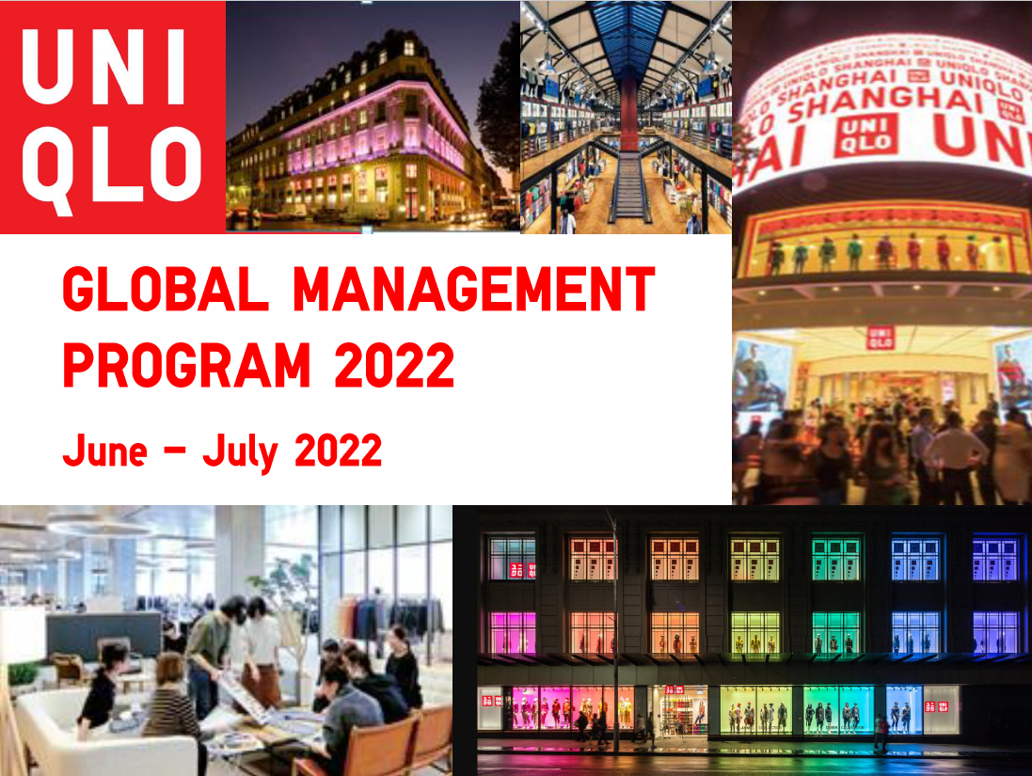

UNIQLO| GLOBAL MANAGEMENT PROGRAM 2022
GMP是UNIQLO推出為期5天的全球菁英挑戰營，你可以與來自各國的菁英交流，更可以與日本總部高階主管共同討論企業發展策略，透過實際案例討論與發表，向全球最優秀的菁英與經營者學習！
∎ 申請資格：建議大三以上/研究所在學生
∎ 語言能力：英語聽/說/讀/寫能力流利
∎活動日期：2022年6月-七月(其中五天)
∎ 參加者：來自全世界超過16個國家/地區菁英 約80名
∎ 申請期限：-2022年2月27日
-----------------------
👉即刻申請：https://www.fastretailing.com/employment/en/uniqlo/graduate/gmp/
👉去年精采花絮：
- 【商業筆記】UNIQLO GMP Part1: Before we start… -胡乃中
- 【商業筆記】UNIQLO GMP Part2: During GMP… -胡乃中
- 【2020 UNIQLO GMP 】近距離觀察服飾零售巨頭的難忘冒險-劉祐華
- 【UNIQLO】2020 GMP Program-LifeWear — 站在跨國服飾品牌的肩上學習極致的全球企業管理哲學-鄭軒羽
- 2020 UNIQLO Global Management Program-呂亮瑄

